* **An outline of steps taken to prepare the data**

SQL is used to pull the data and calculate the moving average temperature for 10 years

select c.year,c.city,c.avg_temp as city_temp, g.avg_temp as global_temp ,

round(avg(c.avg_temp) over(order by c.year asc rows between 10 preceding and current row),2) as moving_avg_city,

round(avg(g.avg_temp) over(order by c.year asc rows between 10 preceding and current row),2) as moving_avg_global from city_data c

join global_data g

on

c.year = g.year

where c.city= 'Berlin'

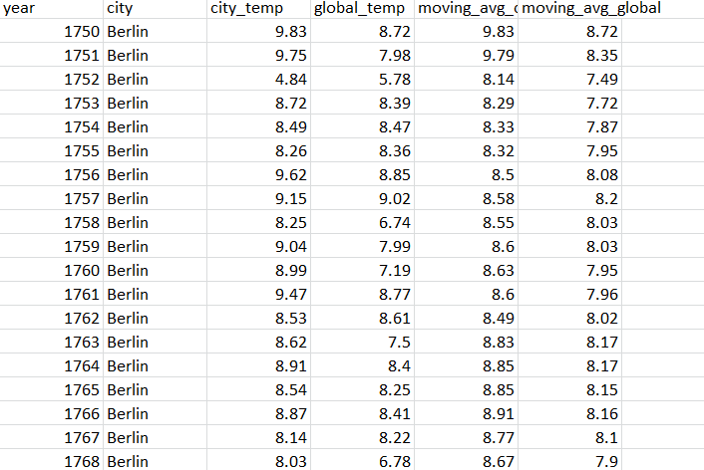

* **Calculate the moving average**

Moving average is calculated for 10 years

* **Line chart with local and global temperature trends**

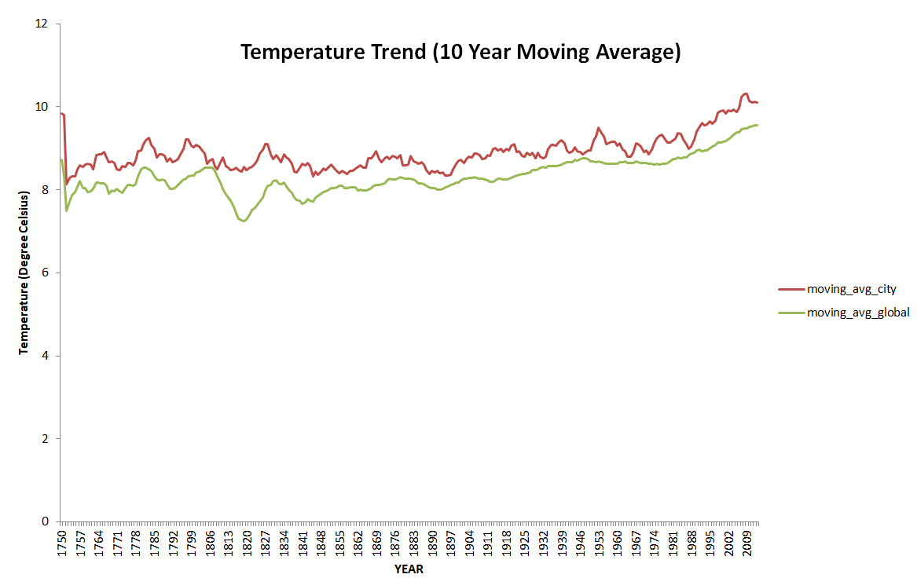

Below mentioned are the observations about the similarities and/or differences in the trends :

* Global temperatures are slightly less as compared to Berlin.
* The temperatures for Berlin as well as global have increased marginally in the last 250 years of data
* The lowest temperatures found for Global (7.24 deg C) around 1819, whereas for Berlin (8.15 deg C) around 1752.
* The global temperature remained consistent until the year 1957, but after 1957 increased. there seems to be a lot of change in temperature.